**Unit test**

Introduction

**Why?**

* Make the code more reliable, can be reused
* Cost less when we recognize bug early
* Easier to fix whenever changes are made

**Note!**

* Test case is independent. Do not call another test case when in a case
* Always checking every single module independently
* Make sure test case names are understandable, unique
* Whenever changes are made, make sure all above test case are tested again
* Bug need to be handle before going to next part
* Do not make ALL test case, only focus on things that can impact the system
* Also need test case for system performance

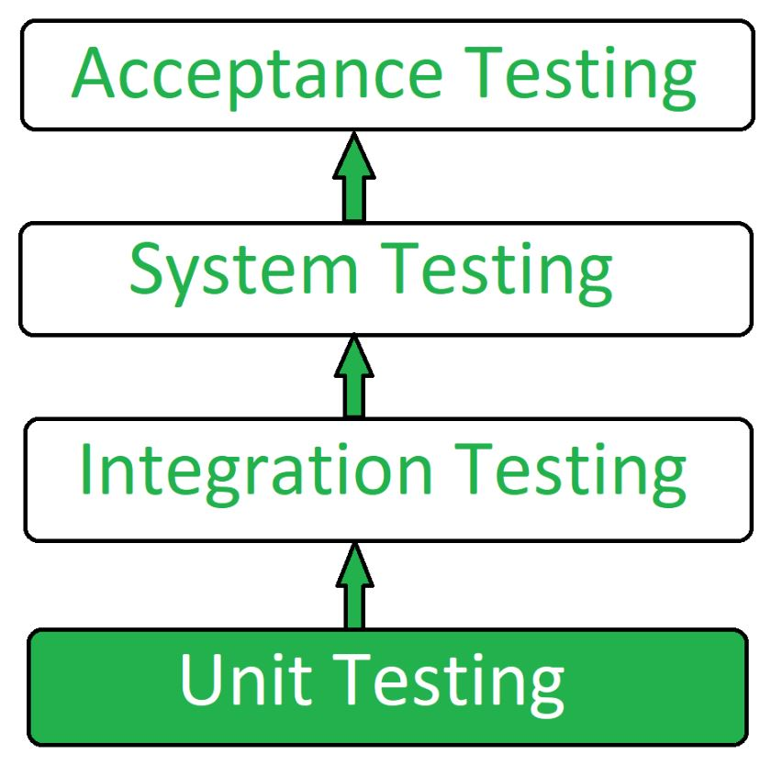

Unit Testing:

* Test focusing on the **smallest units of code**, such as (functions, procedures, subroutines, subprograms, methods, classes)
* Test component in **isolation from the rest** of the system and in a controlled environment (appropriately chosen input data, take guidance from component design)

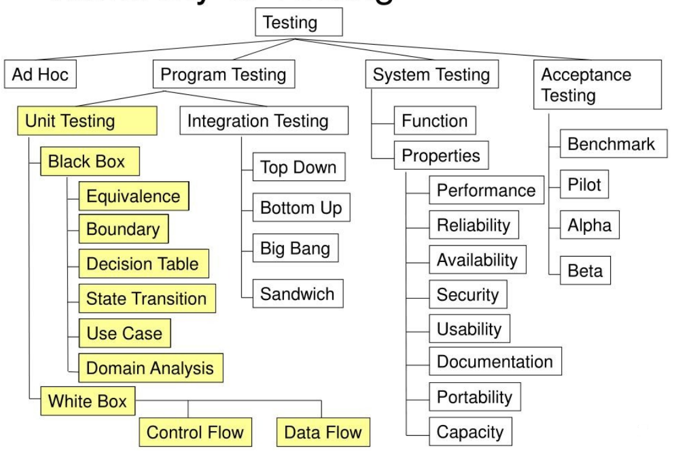

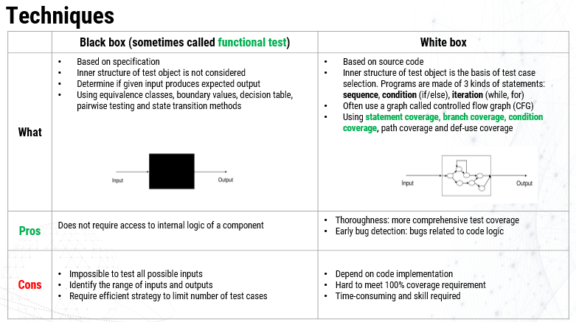

In this section, we focus on **Statement coverage (C0)** and **Branch coverage (C1)** in White box testing

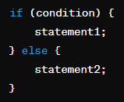

For example we have this function, **Statement coverage** means we make sure that statement1 and statement2 run at least 1 time (do not relevant to condition)

With **Branch coverage**, condition here have 2 branch is true and false, we need to make sure that 2 branchs are executed (do no relevant to statement)

But what happen if ‘condition’ on above example have more than 1 condition:

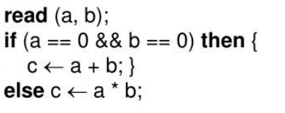

* **Condition coverage (C2)**

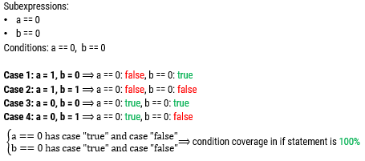

**Modified Condition Decision Coverage (MCDC)** [**https://www.youtube.com/watch?v=DivaWCNohdw**](https://www.youtube.com/watch?v=DivaWCNohdw)

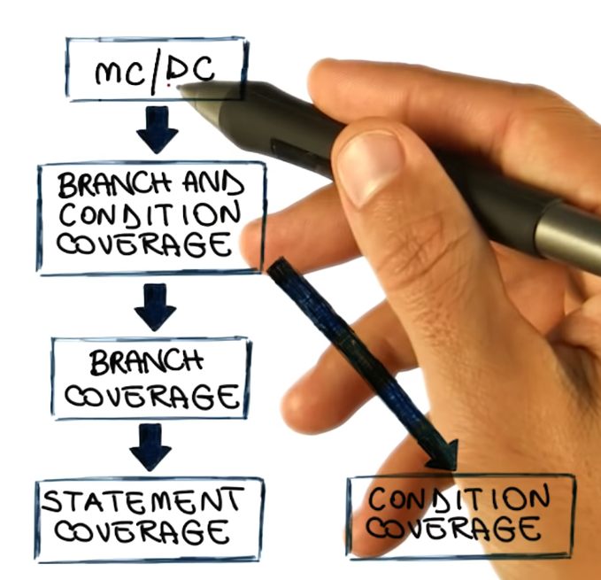

Why?

This includes:

* Branch coverage
* Statement coverage
* Conditions coverage
* Every condition independently affect the outcome (other changes doesn’t affect)

But can decrease the amount of test from 2n to n+1 with n is the number of conditions

**For example:**

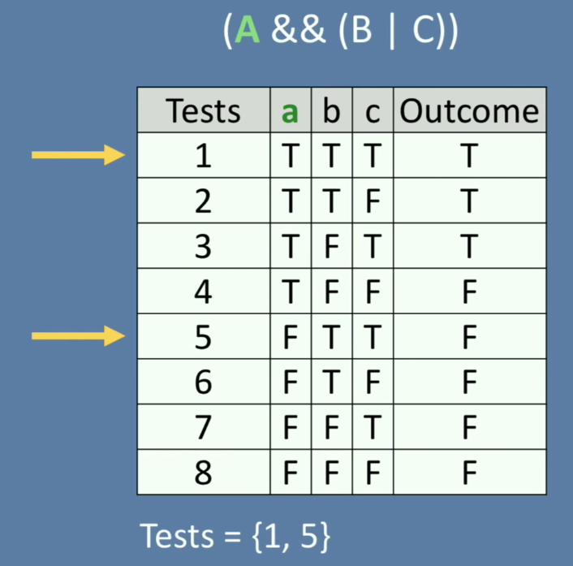

In this example we need to check the independency of A by searching on truth table. Let start with test 1, and we change A from T to F to see if the outcome changes also. And luckily, test 5 show that if we change A -> Outcome change to F. This means B and C changes is not neccesary (these changes are reduntdant -> make our test becomes more complex)

Doing the same way we get test 2 and test 6; test 3 and test 7

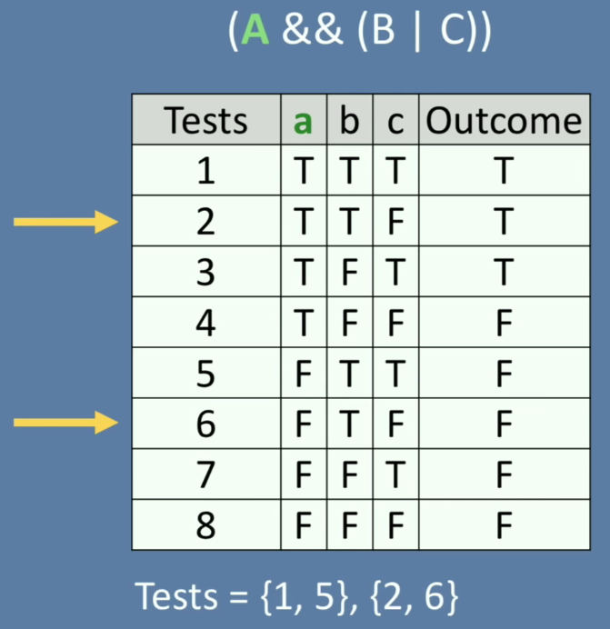

But test 4 and test 8 do not match the rule (outcome is the same)

* With A we got test {1,5,2,6,3,7} that can change the system behavior

Coming to B, we start with fair test 1 and test 3 -> not match

+ Fair 2 and 4 -> match. The rest cases do not match

Coming to C, we only get fair 3 and 4

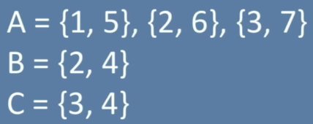

We just need AT LEAST 1 test for each condition -> we got :

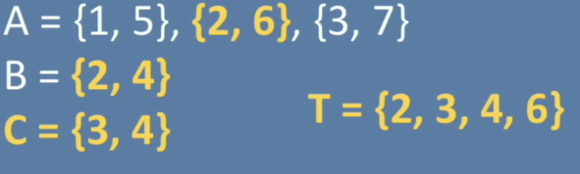

(Why don’t choose {1,5} or {3,7}, here we can pick {3,7} because 3 is in C test case already -> less case. Choose {1,5} is still ok but it increases 1 more case in total)

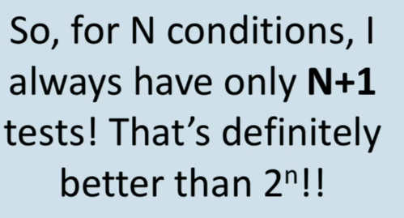

<https://www.youtube.com/watch?v=bwtALQVx86w>

<https://www.youtube.com/watch?v=DivaWCNohdw&list=PLAwxTw4SYaPkoQFThzsc9e7Fe3QV_KJCs&index=69>

If there is no independent condition -> We need to comeback to C0,C1 and C2

Use to remove redundancy in Condition coverage (C2) -> only test the important combination condition

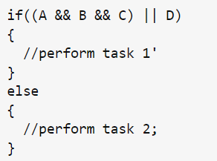

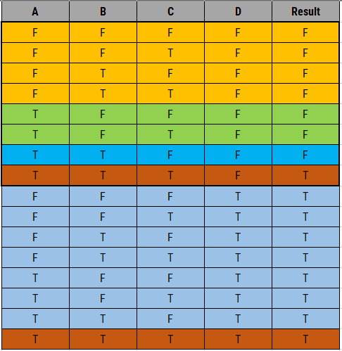 -> 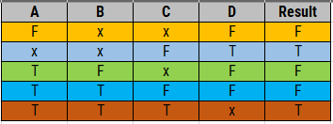

**Example:**

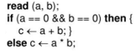

This is how we brainstorm



**Unit test procedures**

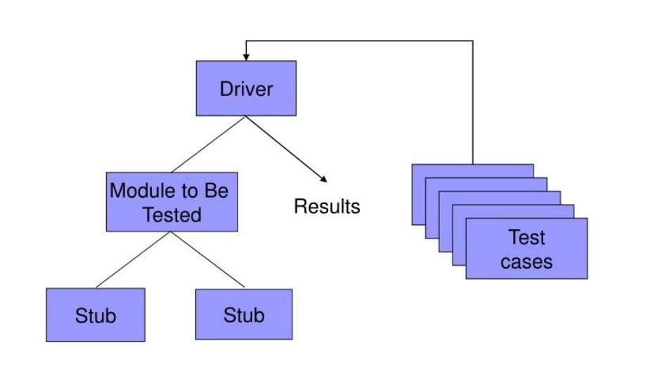

Start with test cases above, after filter necessary test cases(is the core of Unit Test, written by tester), we take it to **Driver**: that can link module to be tested, stub and test cases

* What is stub (stub function/classes,…): Imagine our program need to be tested but some part of it does not complete/already tested, so we need to stimulate the behavior of that part (return an output with specific input). For example the module multiple_two_number(int a, int b) does not complete, we can use stub to take input with a = 2, b=3 and output is 6 without going through calculation inside that function.

**How to perform UT?**

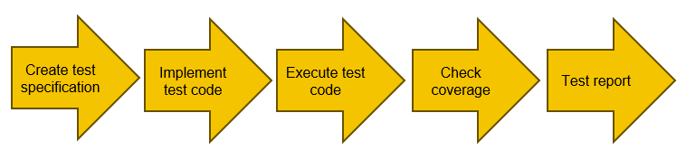

Investigate makefile first:

Dựa trên cấu trúc thư mục và Makefile bạn đã cung cấp, chương trình thực thi UT.exe được tạo ra từ việc biên dịch và liên kết các tệp nguồn C sau:

1. ut_main.c trong thư mục gốc.
2. Các tệp nguồn C trong thư mục framework và các thư mục con của nó (include và util). Framework là nơi các mã nguồn về test được chứa
3. Các tệp nguồn C trong thư mục ut và các thư mục con của nó (config, DMA, include, stub).: Trong thư mục ut chứa các file và các patterns sắp được test

Các tệp nguồn này được biên dịch thành các tệp đối tượng và sau đó được liên kết lại để tạo ra UT.exe. Quá trình này được tự động hóa bởi Makefile.

Vui lòng lưu ý rằng, nếu có thêm các tệp nguồn khác được thêm vào Makefile sau này, chúng cũng sẽ được biên dịch và liên kết vào UT.exe. Hy vọng điều này giúp bạn hiểu rõ hơn! Nếu bạn có thêm câu hỏi, đừng ngần ngại hỏi.

Phần 2 của makefile định nghĩa cấu hình cho việc kiểm tra độ phủ mã nguồn (code coverage) trong quá trình kiểm thử phần mềm. Dưới đây là một số điểm chính:

* **Thư mục Đối tượng và Phụ thuộc**: OBJDIR_COV và DEPDIR_COV được đặt để lưu trữ các tệp đối tượng và phụ thuộc cho việc kiểm tra độ phủ.
* **Thư mục Bao gồm**: INCDIR_COV chứa các đường dẫn đến thư mục bao gồm cần thiết cho việc biên dịch.
* **Nguồn và Đối tượng**: C_DRV_SRC_COV và DRV_OBJS_COV xác định các tệp nguồn và tệp đối tượng tương ứng cho việc kiểm tra độ phủ.
* **Cờ Độ Phủ**: COVERAGE_FLAG được thêm vào để kích hoạt các tùy chọn liên quan đến việc kiểm tra độ phủ trong quá trình biên dịch.
* **Tệp Đầu ra**: OUTPUT_COV là tên của tệp thực thi được tạo ra sau khi liên kết các tệp đối tượng.
* **Quy trình Kiểm tra Độ Phủ**: Các quy tắc coverage và $(OUTPUT_COV) định nghĩa cách tạo ra tệp thực thi kiểm tra độ phủ.
* **Dọn dẹp**: Phần clean định nghĩa cách xóa các tệp và thư mục tạm thời được tạo ra trong quá trình biên dịch và liên kết.

Đây là những thành phần cơ bản của một makefile được sử dụng để tự động hóa quá trình kiểm tra độ phủ mã nguồn trong phát triển phần mềm.

**In ut_main.c**

**Variable for c0c1 checking process**

/* C0C1 */

bool DMA_API_C0C1_line_activate_list[SIZE_OF_LIST];

bool data_format_convert_C0C1_line_activate_list[SIZE_OF_LIST];

bool pre_check_config_C0C1_line_activate_list[SIZE_OF_LIST];

bool check_image_and_square_C0C1_line_activate_list[SIZE_OF_LIST];

bool check_noise_C0C1_line_activate_list[SIZE_OF_LIST];

bool crop_image_and_divide_C0C1_line_activate_list[SIZE_OF_LIST];

uint8_t DMA_API_C0C1_list[SIZE_OF_LIST] = {0};

uint8_t data_format_convert_C0C1_list[SIZE_OF_LIST] = {0};

uint8_t pre_check_config_C0C1_list[SIZE_OF_LIST] = {0};

uint8_t check_image_and_square_C0C1_list[SIZE_OF_LIST] = {0};

uint8_t check_noise_C0C1_list[SIZE_OF_LIST] = {0};

uint8_t crop_image_and_divide_C0C1_list[SIZE_OF_LIST] = {0};

uint32_t DMA_API_C0C1_count = 0;

uint32_t data_format_convert_C0C1_count = 0;

uint32_t pre_check_config_C0C1_count = 0;

uint32_t check_image_and_square_C0C1_count = 0;

uint32_t check_noise_C0C1_count = 0;

uint32_t crop_image_and_divide_C0C1_count = 0;

Các biến và mảng được liệt kê ở trên được sử dụng để kiểm tra và ghi nhận việc thực thi các dòng mã (line) trong các hàm hoặc phương thức cụ thể trong chương trình. Dưới đây là mô tả của từng biến và mảng:

1. `DMA_API_C0C1_line_activate_list`, `data_format_convert_C0C1_line_activate_list`, `pre_check_config_C0C1_line_activate_list`, `check_image_and_square_C0C1_line_activate_list`, `check_noise_C0C1_line_activate_list`, `crop_image_and_divide_C0C1_line_activate_list`: Đây là các mảng boolean dùng để đánh dấu việc thực thi của từng dòng mã trong các hàm tương ứng. Mỗi phần tử của mảng đại diện cho việc thực thi của một dòng mã trong một hàm cụ thể.

2. `DMA_API_C0C1_list`, `data_format_convert_C0C1_list`, `pre_check_config_C0C1_list`, `check_image_and_square_C0C1_list`, `check_noise_C0C1_list`, `crop_image_and_divide_C0C1_list`: Đây là các mảng uint8_t dùng để ghi nhận kết quả của việc thực thi dòng mã tương ứng. Mỗi phần tử của mảng sẽ được gán giá trị 0 nếu dòng mã tương ứng không được thực thi và sẽ được gán giá trị khác 0 nếu dòng mã được thực thi.

3. `DMA_API_C0C1_count`, `data_format_convert_C0C1_count`, `pre_check_config_C0C1_count`, `check_image_and_square_C0C1_count`, `check_noise_C0C1_count`, `crop_image_and_divide_C0C1_count`: Đây là các biến uint32_t dùng để đếm số lượng dòng mã được thực thi trong các hàm tương ứng. Mỗi biến sẽ ghi nhận số lượng dòng mã được thực thi trong hàm tương ứng.

Các biến và mảng này được sử dụng để kiểm tra bao phủ mã (code coverage) và đánh giá chất lượng của mã nguồn trong quá trình kiểm thử.

* Dưới đây là một ví dụ về cách các biến được sử dụng trong quá trình kiểm thử:

Giả sử chúng ta có một hàm `check_image_and_square`, và chúng ta muốn kiểm tra xem bao nhiêu dòng mã trong hàm này được thực thi và ghi nhận kết quả thực thi của từng dòng mã.

```c

// Hàm check_image_and_square để kiểm tra và xử lý hình ảnh

void check_image_and_square(int image_id) {

// Đoạn mã kiểm tra và xử lý hình ảnh

// ...

if (image_id % 2 == 0) {

// Task 1

// ...

} else {

// Task 2

// ...

}

}

```

1. Đầu tiên, khi chạy hàm kiểm thử, các biến `check_image_and_square_C0C1_line_activate_list`, `check_image_and_square_C0C1_list` và `check_image_and_square_C0C1_count` sẽ được sử dụng.

2. Trong quá trình thực thi hàm `check_image_and_square`, mỗi dòng mã sẽ được kiểm tra xem nó có được thực thi hay không. Nếu dòng mã được thực thi, thì phần tử tương ứng trong mảng `check_image_and_square_C0C1_line_activate_list` sẽ được đánh dấu là true, và giá trị tương ứng trong mảng `check_image_and_square_C0C1_list` sẽ được ghi nhận.

3. Sau khi kết thúc thực thi hàm `check_image_and_square`, biến `check_image_and_square_C0C1_count` sẽ chứa tổng số lượng dòng mã được thực thi trong hàm.

4. Dựa trên kết quả này, bạn có thể đánh giá bao phủ mã (code coverage) của hàm `check_image_and_square` và xác định xem các dòng mã nào đã được thực thi và dòng mã nào chưa được thực thi trong quá trình kiểm thử.

**Log_C0C1 function in ut_main.c**

void log_C0C1(char* function_name, uint32_t C0C1_count, uint8_t* C0C1_list, uint32_t total) {

    for (uint32_t i = 0; i < SIZE_OF_LIST; i++) {

        C0C1_count += C0C1_list[i];

    }

    if(C0C1_count < total) {

        printf(ANSI_COLOR_RED "[V][RESULT][%3d%%] C0C1 coverage of %-23s, statements covered: [ACTUAL] %d <==> [EXPECTED] %d\n" ANSI_COLOR_RESET, (C0C1_count*100/total), function_name, C0C1_count, total);

    }

    else {

        printf(ANSI_COLOR_GREEN "[V][RESULT][%3d%%] C0C1 coverage of %-23s, statements covered: [ACTUAL] %d <==> [EXPECTED] %d\n" ANSI_COLOR_RESET, (C0C1_count*100/total), function_name, C0C1_count, total);

    }

}

This part show up the final result in UT_coverage

* **Ut_main.c is for UT_coverage.exe**

UT.exe : Environment configuration

Make for this part:

#--------------------------------------------------------------

# For Environment Configurations

#--------------------------------------------------------------

TEST_CONFIGS  += -DTEST_ENV_UT

TEST_CONFIGS  += -DWINDOWS_OS

TEST_CONFIGS  += -DNDEBUG

EXTRA_CFLAGS += -std=c99 -g -O0

CC := gcc

LD := g++

OUTPUT  = UT.exe

# CANTPP_CMD = cppccd "--comp:x86-Win32-gpp8.2-bundled" --no_link

# CANTPP_LD_CMD = cppccd "--comp:x86-Win32-gpp8.2-bundled"

# CANTPP_TARGET_OPTS = "--parse:--line_directives" "--parse:-W2" "--sm:--call_seq_code" "--ci:--instr:func;call;stmt;decn;log;" "--analyse"

TEST_CONFIGS += -DWIN32

all: $(OUTPUT)

$(OUTPUT) : $(OBJS) $(DEPLIB)

    $(CANTPP_LD_CMD) $(CANTPP_TARGET_OPTS) $(LD) -o $@ $(OBJS)

$(OBJDIR)/%.c.o: ./%.c

    $(eval ODIR=$(dir $@))

    $(eval DDIR=$(subst $(OBJDIR)/,$(DEPDIR)/,$(ODIR)))

    @if NOT EXIST $(subst /,\\,$(ODIR)) (mkdir $(subst /,\\,$(ODIR)))

    @if NOT EXIST $(subst /,\\,$(DDIR)) (mkdir $(subst /,\\,$(DDIR)))

    $(CC) $(INCDIR) $(EXTRA_CFLAGS) $(TEST_CONFIGS) -MD -MF $(addprefix $(DEPDIR)/,$(subst .c,.c.d,$<)) -c -o $(subst ./$(OBJDIR)/,./,$@)  $<

./obj/src/DMA.c.o: $(abspath ../src/DMA.c)

    $(eval ODIR=$(dir $@))

    $(eval DDIR=$(subst ./$(OBJDIR)/src/obj,./$(OBJDIR)/src/dep,$(ODIR)))

    @if NOT EXIST $(subst /,\\,$(ODIR)) (mkdir $(subst /,\\,$(ODIR)))

    @if NOT EXIST $(subst /,\\,$(DDIR)) (mkdir $(subst /,\\,$(DDIR)))

    $(CANTPP_CMD) $(CANTPP_TARGET_OPTS) $(CC) $(INCDIR) $(EXTRA_CFLAGS) $(TEST_CONFIGS) -MD -c -o $@ $<

-include $(DEPS)

The difference between UT.exe and UT_coverage.exe is the path to get source code:

* UT.exe: ./obj/src/DMA.c.o: $(abspath ../src/DMA.c)
* UT_coverage.exe :
  + COVERAGE_FLAG += -DCHECK_COVERAGE
  + ./obj_cov/src/DMA.c.o: $(abspath ../../source_coverage/src/DMA.c)
* Information printed out from **UT_coverage.exe** and **UT.exe** is both from testfw.c

In ut_main.c we can see that there is a line call **“TEST_MAIN(argc, argv)”**

This line lead to **TEST_UT_main** that is defined in **ut.c** (extern from **testfw.c**) and execute TEST_main

**In TEST_main:**

TEST_main(argc, argv, "UT", "MODULE_TEST", TEST_UT_Info);

We tranfer an argument TEST_UT_Info here, so there is a place to input more Unit Test for this framework

* It will run TEST_ParseArges to check option input (autorun or not ?)
* In this test we do not input anything (autorun???) so this function will run **TEST_RunAllTests -> TEST_RunTest**
* Only ILOG print out message, FLOG doesn’t print anything (???why)

The **TEST_main** function is the primary function used to initialize and run tests. Here's what each argument in this function means:

1. **argc**: This is the number of command-line arguments passed into the program. In C/C++ applications, **argc** is often used to count the number of arguments passed in from the command line.
2. **argv**: This is the array containing pointers to command-line arguments. Each element of this array is a pointer pointing to a string of characters (command-line arguments). Typically, **argv[0]** is the name of the program.
3. **env**: This argument represents the environment of the test. In the context of this function, can be used to define specific test environments or certain environment configurations.
4. **target**: This argument specifies the goal or scope of the test. This can be the name of the module, function, or other test scope.
5. **testInfo**: This argument is a pointer to a **TestInfo** structure, which contains information about the tests defined. The **TestInfo** structure can contain descriptions of test functions, including names, types, test subfunctions, and other information required for test execution.

The specific example **TEST_main(argc, argv, "UT", "MODULE_TEST", TEST_UT_Info)** means:

1. The program is launched with the number of command-line arguments, and the arguments are passed through **the argv array**.
2. The test environment is set to **"UT"** (assuming "UT" means "Unit Test").
3. The test objective is set as **"MODULE_TEST".**
4. Information about the tests is taken from the **TEST_UT_Info** variable.

**TEST_UT_Info in /ut/include/test_case.h : get the test cases list**

By using

DECLARE_TESTCASE_TABLE(DMA_API);

Which is equivalent to:

extern struct TestCase UT_DMA_API_All_Tests[];

so that we can investigate that struct inside **DMA_API_table.c**

TEST_CASE_F(UT, DMA_API, RPI3, DMA_API_0001) { EXPECT_EQ( true, TEST_DMA_API("PCL", 1)); }

struct TestCase UT_DMA_API_All_Tests[] = {

    TEST_CASE_T(UT, DMA_API, RPI3, DMA_API_0001, DMA_API_0001), //{ "UT", "DMA_API", "RPI3", "DMA_API_0001", UT_DMA_API_DMA_API_0001_RPI3_Test }

    TEST_CASE_END

};

So after going into this file, we can see 2 macro TEST_CASE_F (test case function) and TEST_CASE_T (test case type) and can be explored in testenv.h

#define TEST_CASE_F(type, func, target, id)\

    void type##_##func##_##id##_##target##_Test()

#define TEST_CASE_T(type, func, target, funcid, id)\

    { #type, #func, #target, #id, TEST_FUNC_NAME(type##_##func, target, funcid) }

And so many macros apply on this, finally we got this:

void UT_DMA_API_DMA_API_0001_RPI3_Test()

{

    bool result = TEST_DMA_API("PCL", 1);

    if (result == true)

    {

        printf("[          OK ] %s (from testenv.h)\n\n\n\n", g_test.runningTestName);

        g_test.passed++;

    }

    else

    {

        printf("%s:%d: Failure\n", __FILE__, __LINE__);

        printf("\tExpected: %s\n", (true) ? "true" : "false");

        printf("\tWhich is: %s\n", (result) ? "true" : "false");

        printf("[          NG ] %s\n", g_test.runningTestName);

        g_test.failed++;

    }

}

bool TEST_DMA_API(const char *category, int32_t no)

{

    bool b = true;

    struct TestParams *params = TEST_CreateParam("DMA_API", category, no);

    struct TEST_DMA_API_Pattern *pattern = &DMA_API_PCL[no - 1];

    struct DMA_API_input *inputs = &pattern->input;

    struct DMA_API_params func_params = {0};

    struct DMA_API_expect outputs = {0};

    ut_init_config(false);

    memcpy(&func_params.x, &inputs->x, sizeof(func_params.x));

    memcpy(&func_params.y, &inputs->y, sizeof(func_params.y));

    if (inputs->_p_dma_config == TEST_ADDR_NULL)

    {

        func_params.p_dma_config = NULL;

    }

    else

    {

        func_params.p_dma_config = &inputs->p_dma_config;

    }

    outputs.ReturnValue = DMA_API(func_params.x, func_params.y, func_params.p_dma_config);

    if (pattern->expected._p_dma_config == TEST_ADDR_NULL || pattern->expected._p_dma_config == TEST_ADDR_NOT_NULL)

    {

        outputs._p_dma_config = (func_params.p_dma_config == NULL) ? TEST_ADDR_NULL : TEST_ADDR_NOT_NULL;

    }

    else

    {

        outputs._p_dma_config = (uint32_t)func_params.p_dma_config;

    }

    if (func_params.p_dma_config != NULL)

    {

        memcpy(&outputs.p_dma_config, func_params.p_dma_config, sizeof(outputs.p_dma_config));

    }

    b &= TEST_GetAddr_DMA_API(&pattern->expected._p_dma_config, &func_params);

    b &= TEST_Validate_DMA_API(&outputs, &pattern->expected, pattern->validator);

    TEST_ValidateResult(b, params);

    ut_deinit_config();

    TEST_DestroyParam(params);

    return b;

}

**Operation process**:

1. When you call **UT_DMA_API_DMA_API_0001_RPI3_Test** function in your program, it performs steps in its body.
2. First, it will call the **TEST_DMA_API** function to perform the test and assign the result to the **result variable**.
3. It will then check this result using the **EXPECT_EQ macro**.
4. The results of the test will be printed to the screen and the variables **g_test.passed** or **g_test.failed** will be increased accordingly to count the number of tests that have succeeded or failed.

OK, so in **DMA_API_table.c,** we can find out the function **UT_DMA_API_DMA_API_0001_RPI3_Test()** that include the pattern for Unit Test: (which stored in **DMA_API_PCL.h**)

    struct TEST_DMA_API_Pattern *pattern = &DMA_API_PCL[no - 1];

In which stores all pattern that we prepared in **test_spec_ref.xlxs** . So at this point, we can barely understand that file start will **\*_table.c** and **\*_PCL.h** can affect the result in **C0C1 and C2 coverage check**

That makes sense to the changes in % coverage of that function, but what happens if we want to test another module/function ? Let’s look back at **TEST_UT_Info in /ut/include/test_case.h** to add another **TESTCASE_TABLE** into that.

**Test_case.h in /ut/include/**

#define DECLARE_TESTCASE_TABLE(func)    extern struct TestCase UT_##func##_All_Tests[]

#define TESTCASE_TABLE(category,func) { #func,  category,   UT_##func##_All_Tests   }

To add a list of test cases (test case table), we need to declare in **test_case.h** by using DECLARE_TESTCASE_TABLE and add TESTCASE_TABLE into TestInfo TEST_UT_Info[]. For example:

DECLARE_TESTCASE_TABLE(DMA_API); //extern struct TestCase UT_DMA_API_All_Tests[]

static const struct TestInfo TEST_UT_Info[] =

{

    TESTCASE_TABLE("DMA", DMA_API), // { "DMA_API", "DMA", UT_DMA_API_All_Tests }

{ NULL, "", NULL }

};

* Workflow: from ut_main.c
* ut.c with **TEST_main**(argc, argv, "UT", "MODULE_TEST", **TEST_UT_Info**) in this function we have **TEST_RunAllTest** that execute **TEST_RunTest** with info taken from **TEST_UT_Info** multiple times ->
* **TEST_UT_Info** in **test_case.h** include struct **UT_DMA_API_All_Tests[]** (that extern from **DMA_API _table.c**) ->
* **UT_DMA_API_All_Tests[]** include function **UT_DMA_API_DMA_API_00xx_RPI3_Test()** in which xx is the number of test ->
* this function include **TEST_DMA_API()** that process the test by ->
  + take the pattern ‘**struct** **TEST_DMA_API_Pattern DMA_API_PCL[]**’ in **DMA_API_PCL.h**
  + This func input a whole pattern and split it into 3 part :
    - **‘struct DMA_API_input’** 
      * -> split into multiple input into ‘**struct DMA_API_params func_params’**
    - **struct DMA_API_expect outputs**: to get output expected -> compare. But we need to run the function we want to test and get it result (!note: do not call another function in when testing a specific function, if we are forced to to this, we can use **stub function** (stub function does not execute code, they just give a fixed return value) instead)
      * Run **DMA_API(func_params.x, func_params.y, func_params.p_dma_config)** with parameters store in **‘struct param’**. Store the result into **struct DMA_API_expect outputs.** !note that **DMA_API()** have 2 declaration in **Data\scr** for **UT.exe** and **source_coverage\src** for **UT_coverage.exe** (depend on makefile)

!note: We didn’t check coverage here due to the macro CHECK_COVERAGE is not active

**#ifdef CHECK_COVERAGE : UNLOCK COVERAGE PART**

#--------------------------------------------------------------

# For Coverage Configurations

#--------------------------------------------------------------

COVERAGE_FLAG += -DCHECK_COVERAGE

By using this flag, we can active all the code between:

#ifdef CHECK_COVERAGE

//Our code here, only active when findout the flag CHECK_COVERAGE

#endif

So to this point, we can active all the code relavant to coverage.

As we investigate above, within coverage part we have source code for **DMA_API()** is in the source_coverage\src, where we can see 2 ‘macro’ (not function): **C0C1_checker** and **C2_checker** in **coverage_checker.h**

#define C0C1_checker(line_C0C1_is_activated, function_count_C0C1) \

    if (line_C0C1_is_activated) {\

        function_count_C0C1 = 1; \

        line_C0C1_is_activated = false;}

#define C2_checker(subexpression_C2_is_activated, subexpression, function_count_C2_true, function_count_C2_false) \

    if (subexpression_C2_is_activated) {\

        if (subexpression) {\

            function_count_C2_true = 1;} \

        if (!(subexpression)) {\

            function_count_C2_false = 1;} \

        if (function_count_C2_true == 1 && function_count_C2_false == 1) {\

            printf(ANSI_COLOR_GREEN "[V] The subexpression: %s passed C2 coverage check (from coverage_checker.h)\n" ANSI_COLOR_RESET, STRINGIFY(subexpression)); \

            subexpression_C2_is_activated = false;}}

[Why don’t we use function and call them ?](https://learn.microsoft.com/en-us/cpp/c-runtime-library/recommendations-for-choosing-between-functions-and-macros?view=msvc-170) Because the main requirement of unit test contain speed and we call this ‘function’ multiple time -> so that we can use macro to speed up

!note: if we want to add printf to macro for debugging, we need to ‘make clean’ before ‘make coverage’ again. We can use color code [Color codes for console using Ansi (github.com)](https://gist.github.com/raghav4/48716264a0f426cf95e4342c21ada8e7) to make our code easier to observe.

**line_C0C1_is_activated** and **subexpression_C2_is_activated** is active inside **ut_main.c**

We can take randomly C0C1_checker() and C2_checker() to examine its function:

C0C1_checker(DMA_API_C0C1_line_activate_list[3], DMA_API_C0C1_list[3]);

    /*

    if (DMA_API_C0C1_line_activate_list[3]) {

        DMA_API_C0C1_list[3] = 1;

        DMA_API_C0C1_line_activate_list[3] = 0;

    }

    */

With this function, just to make sure we can get inside that part of code (usually inside a bracket {})

C2_checker(DMA_API_C2_subexpression_activate_list[3], x >= p_dma_config->offset_x, DMA_API_C2_list_true[3], DMA_API_C2_list_false[3]);

            /*

            if (DMA_API_C2_subexpression_activate_list[3])

            {

                if (x >= p_dma_config->offset_x) {

                        DMA_API_C2_list_true[3] = 1;

                    }

                        if (!(x >= p_dma_config->offset_x)) {

                            DMA_API_C2_list_false[3] = 1;

                        }

                        if (DMA_API_C2_list_true[3] == 1 && DMA_API_C2_list_false[3] == 1) {

                                printf("\x1b[32m" "[V] The subexpression: %s passed C2 coverage check (from coverage_checker.h)\n" "\x1b[0m", "x >= p_dma_config->offset_x");

                                DMA_API_C2_subexpression_activate_list[3] = 0;

                            }

                        }

            */

This function is to make sure that every single subexpression (for example with if(A&&B&&C), A B and C is subexpression) perform both true and false cases.

**Stub function**

What happens if our testing function call another or… 100 other functions ? If we just let it calls those 100 functions, if an error occur, how can we know that 100 functions is not the root problems ? So in this case, we need to stimulate their process by using a fake function that only return a fixed value with certain input. We call it **stub function.**

Firstly, we need to look at

e_validation_t pre_check_config(st_config_t* p_config)

{

DMA_API(……);//line 33

DMA_API(……);//line 34

In this function, they call **DMA_API**, so we can guest that program will use stub function here. Clearly, we can find out in **config_ut.c** having a macro that change **DMA_API** into stub function **DMA_API_stub**.

From that we can find out **DMA_API_stub** is declared in **stub.c**.

e_validation_t DMA_API_stub(uint16_t x, uint16_t y, const st_DMA_config_t* p_dma_config)

{

    e_validation_t ret_func;

    if (NULL != g_hook_DMA_API)

    {

        ret_func = g_hook_DMA_API(x, y, p_dma_config);

        //g_hook_DMA_API = ut_stub_DMA_API; we use g_hook_DMA_API as a middleman here

        //because we still want to declare ut_stub_DMA_API but can controll the use

        //of DMA_API_stub. What happens if we want to skip the stub or change to

        //another stub without changing the source code in here ?

    }

    else

    {

        ret_func = DMA_API(x, y, p_dma_config);

    }

    return ret_func;

}

e_validation_t ut_stub_DMA_API(uint16_t x, uint16_t y, const st_DMA_config_t* p_dma_config)

{

    s_DMA_API *IO = &g_DMA_API;

    e_validation_t ReturnValue;

    ReturnValue = IO->ReturnValue[IO->ut_index];

    IO->ut_index++;

    return ReturnValue;

}

**DMA_API_stub** will call **ut_stub_DMA_API** through **g_hook_DMA_API**:

(in **TEST_pre_check_config()**)

One more thing we need to figure out: inside **ut_stub_DMA_API** we see the **g_DMA_API** is declared, but how can it connect to the pattern to take the result out (we fake its process by give a result already). Keep investigating **TEST_pre_check_config()**:

struct TEST_pre_check_config_Pattern *pattern = &pre_check_config_PCL[no - 1];

struct pre_check_config_input  *inputs = &pattern->input;

bool is_stub = !inputs->DMA_API.is_stub;

…

    if (inputs->DMA_API.is_stub)

    {

memcpy(&g_DMA_API.ReturnValue, &inputs->DMA_API.ReturnValue, sizeof(inputs->DMA_API.ReturnValue));

        g_hook_DMA_API = ut_stub_DMA_API;

    }

Here we go, we can give an output of **DMA_API** in **pre_check_config_PCL.h** . We can have a look at **pre_check_config.h** to understand the struct of the pattern:

struct TEST_pre_check_config_Pattern {

    struct pre_check_config_input

    {

        uint32_t _p_config;

        struct DMA_API_info

        {

            e_validation_t ReturnValue;

            bool is_stub;

        } DMA_API;

        typedef struct

        {

            typedef struct

            {

                uint32_t width_of_image;

                uint32_t height_of_image;

                uint32_t crop_size;

            }st_image_size_t image_config;

            typedef struct

            {

                uint8_t square_width;

                uint8_t square_height;

                uint8_t square_shift;

            }st_square_t; square_config;

            typedef struct

            {

                uint32_t offset_x;

                uint32_t offset_y;

                uint32_t width;

                uint32_t height;

                bool enable;

                bool exclude;

            } st_DMA_config_t; dma_config;

        }st_config_t image_info; //personally added

    } input;

    struct pre_check_config_expect{

        e_validation_t ReturnValue;

    } expected;

};

Notice that we need to add **st_config_t image_info;** in order to perform more testcase to cover C0 C1 C2. We need to make changes to pre_check_config.c and pre_check_config.h:

    else

    {

        func_params.p_config = &g_uts_p_config;

        func_params.p_config->image_config = inputs->image_info.image_config; //personally added

        func_params.p_config->square_config = inputs->image_info.square_config; //personally added

    }

And

static struct TEST_pre_check_config_Pattern pre_check_config_PCL[] =

{

    /* "Test Case ID         ",      *p_config         ,   DMA_API   is_stub  , image_config    square_config}, { ReturnValue ,  */

    /* pre_check_config_0001 */ { { TEST_ADDR_NOT_NULL , { E_FAILURE, TRUE   },{{0,0,0}     ,   {0,0,0}     }}, { E_FAILURE    } }

};

How to make a new test file including **check_image_and_square.c, check_image_and_square_table.c, check_image_and_square.h, check_image_and_square_PCL.h** ? Update **function.h, test_case.h**

* In **ut.c** we include both **test_case.h** and **testenv.h**, so when we extern a function in **test_case.h**, compiler will find the declaration of that function that trace back to **ut.c** -> **testenv.h** -> file which included **testenv.h** (that is where **check_image_and_square.c** include)

Let’s look back at **DMA_API.c** to see how the test is built. Now apply to **check_image_and_square.c**:

* Firstly, we have **TEST_GetAddr_check_image_and_square** to check if the expected pointer is NULL or not, if not NULL -> store into an array through **Test_set_validate_pointer_info** . (Add this function if we have pointer in our ‘test function’)

static bool TEST_GetAddr_check_image_and_square(uint32_t *flag, struct check_image_and_square_params *func_params)

{

    bool ret = true;

    switch (*flag)

    {

    case TEST_ADDR_NOT_NULL:

        ret = Test_set_validate_pointer_info((uint32_t)TEST_ADDR_NOT_NULL, "not null\0");

        break;

    default:

        break;

    }

    return ret;

}

* Next, we must have **TEST_Validate_check_image_and_square:** to check if our input and output are the same or not

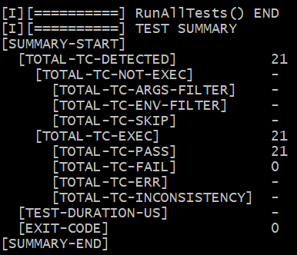 The result will be stored and written here.

/*Test Return value, p_image->width_of_image and p_image->height_of_image.*/

static bool TEST_Validate_check_image_and_square(struct check_image_and_square_expect *outputs, struct check_image_and_square_expect *expected, bool validator[])

{

    bool b = true;

    uint64_t index = 0;

    b &= TEST_ValidateOutput(&outputs->ReturnValue, &expected->ReturnValue, sizeof(outputs->ReturnValue), "ReturnValue", TEST_VALIDATOR_RETCODE);

    if (TEST_CheckBitValidator(validator, index++))

    {

        b &= TEST_ValidateOutput(&outputs->p_image.width_of_image, &expected->p_image.width_of_image, sizeof(outputs->p_image.width_of_image), "p_image.width_of_image", TEST_VALIDATOR_I32VALUE);

    }

    if (TEST_CheckBitValidator(validator, index++))

    {

        b &= TEST_ValidateOutput(&outputs->p_image.height_of_image, &expected->p_image.height_of_image, sizeof(outputs->p_image.height_of_image), "p_image.height_of_image", TEST_VALIDATOR_I32VALUE);

    }

    return b;

}

* Then we must have **TEST_check_image_and_square** **(const char *category, int32_t no)** (update in function.h )
  + Initialize parameters:

    //Parameter init

    bool b = true;

    struct TestParams *params = TEST_CreateParam("check_image_and_square", category, no);

    struct TEST_check_image_and_square_Pattern *pattern = &check_image_and_square_PCL[no - 1];

    struct check_image_and_square_input *inputs = &pattern->input;

    struct check_image_and_square_params    func_params = {0};

    struct check_image_and_square_expect    outputs = {0};

    ut_init_config(false);

* + Copy data from input of pattern to **func_params**:

/*Copy 4 parameter in input struct to function parameter*/

    //Copy data from input to function parameters - 1 and 2

    memcpy(&func_params.p_image, &inputs->p_image, sizeof(func_params.p_image));

    memcpy(&func_params.p_square, &inputs->p_square, sizeof(func_params.p_square));

    //copy pointer for p_image - 3

    if (inputs->_p_image == TEST_ADDR_NULL)

    {

        func_params.p_image = NULL;

    }

    else

    {

        func_params.p_image = &inputs->p_image;

    }

    //copy pointer for p_square - 4 done

    if (inputs->_p_square == TEST_ADDR_NULL)

    {

        func_params.p_square = NULL;

    }

    else

    {

        func_params.p_square = &inputs->p_square;

    }

* + Execute the function and copy result to **outputs**:

   //run function, store to outputs (3 value + 2 struct*3value_each) - 1

    outputs.ReturnValue = check_image_and_square(func_params.p_image, func_params.p_square);

    //Just check NULL/NOT_NULL or implement a specific address ? for p_image - 2

    if (pattern->expected._p_image == TEST_ADDR_NULL || pattern->expected._p_image == TEST_ADDR_NOT_NULL)

    {

        outputs._p_image = (func_params.p_image == NULL) ? TEST_ADDR_NULL : TEST_ADDR_NOT_NULL;

    }

    else

    {

        outputs._p_image = (uint32_t)func_params.p_image;

    }

    //copy result to output - 1st struct*3value_each

    if (func_params.p_image != NULL)

    {

        memcpy(&outputs.p_image , func_params.p_image, sizeof(outputs.p_image));

    }

    //Just check NULL/NOT_NULL or implement a specific address ? for p_square - 3

    if (pattern->expected._p_square == TEST_ADDR_NULL || pattern->expected._p_square == TEST_ADDR_NOT_NULL)

    {

        outputs._p_square = (func_params.p_square == NULL) ? TEST_ADDR_NULL : TEST_ADDR_NOT_NULL;

    }

    else

    {

        outputs._p_square = (uint32_t)func_params.p_square;

    }

    //copy result to output - 2nd struct*3value_each DONE

    if (func_params.p_square != NULL)

    {

        memcpy(&outputs.p_square , func_params.p_square, sizeof(outputs.p_square));

    }

* + Check address, validate the results:

    //check address and store to array

    b &= TEST_GetAddr_check_image_and_square(&pattern->expected._p_image, &func_params);

    b &= TEST_GetAddr_check_image_and_square(&pattern->expected._p_square, &func_params);

    b &= TEST_Validate_check_image_and_square(&outputs, &pattern->expected, pattern->validator);

    TEST_ValidateResult(b, params);

    ut_deinit_config();

    TEST_DestroyParam(params);

    return b;

* Done for **check_image_and_square.c**

Now we need to define struct that we will use and store in **check_image_and_square.h**:

#ifndef CHECK_IMAGE_AND_SQUARE_H_

#define CHECK_IMAGE_AND_SQUARE_H_

struct check_image_and_square_input {

    uint32_t _p_image;

    uint32_t _p_square;

    st_image_size_t p_image;

    st_square_t p_square;

};

struct check_image_and_square_expect {

    e_validation_t ReturnValue;

    uint32_t _p_image;

    uint32_t _p_square;

    st_image_size_t p_image;

    st_square_t p_square;

};

struct check_image_and_square_params {

    st_image_size_t *p_image;

    st_square_t *p_square;

};

struct TEST_check_image_and_square_Pattern {

    struct check_image_and_square_input input;

    struct check_image_and_square_expect expected;

    bool validator[3];

};

#endif /* CHECK_IMAGE_AND_SQUARE_H_ */

Note that **_p_image** and **_p_square** just store the state of pointer and its address in interger

Then we need to declare function and add to struct **TestCase** in **check_image_and_square.h**:

#include "testenv.h"

TEST_CASE_F(UT, check_image_and_square, RPI3, check_image_and_square_0001) { EXPECT_EQ( true, TEST_check_image_and_square("PCL", 1)); }

struct TestCase UT_check_image_and_square_All_Tests[] = {

    TEST_CASE_T(UT, check_image_and_square, RPI3, check_image_and_square_0001, check_image_and_square_0001),

    TEST_CASE_END

};

Next, we will declare test case in **check_image_and_square_PCL.h**

#ifndef CHECK_IMAGE_AND_SQUARE_PCL_H

#define CHECK_IMAGE_AND_SQUARE_PCL_H

#include "check_image_and_square.h"

static struct TEST_check_image_and_square_Pattern check_image_and_square_PCL[] =

{

    /* "Test Case ID", { {_p_image,_p_square,{width_of_image, height_of_image,crop_size},{square_width, square_height, square_shift}},{Returnvalue,_p_image,_p_square, {width_of_image, height_of_image,crop_size},{square_width, square_height, square_shift} },{validator,validator,validator,validator,validator,validator,validator,validator} } */

    /* check_image_and_square_0001 */ { { TEST_ADDR_NULL  , TEST_ADDR_NULL , {0,0,0},{0,0,0}},{E_FAILURE,TEST_ADDR_NULL,TEST_ADDR_NULL,{0,0,0},{0,0,0}},{FALSE,FALSE,FALSE}},

};

#endif

Lastly, just update **test_case.h**: to extern the **TestCase** struct and store all of test case in **TEST_UT_Info[]**

Update **function.h**:

**MCDC and checking stub in ex 4 with check_noise function:**

Firstly we need to look back stub above, start adding stub replacement inside **config_ut.c** (just follow the way **DMA_API** did)

#define is_DMA_Check         is_DMA_Check_(__LINE__)

#define is_DMA_Check_(line)  is_DMA_Check__(line)

#define is_DMA_Check__(line) is_DMA_Check_ut_##line

#ifndef CHECK_COVERAGE

    /* "40" is the line number where DMA_API is called in function pre_check_config in file config.c

       Update this number if the DMA_API is no longer in line 40 */

    #define is_DMA_Check_ut_70    is_DMA_Check_stub

#else

    /* "107" is the line number where DMA_API is called in function pre_check_config in file config.c (source_coverage)

       Update this number if the DMA_API is no longer in line 107 */

    #define is_DMA_Check_ut_107 is_DMA_Check_stub

    #define is_DMA_Check_ut_108 is_DMA_Check_stub

#endif

#include "config.c"

#undef is_DMA_Check

Now we head to **stub.c** to update 2 function:

//is_DMA_Check added

e_validation_t ut_stub_is_DMA_Check(void)

{

    s_is_DMA_Check *IO = &g_is_DMA_Check;

    e_validation_t ReturnValue;

    ReturnValue = IO->ReturnValue[IO->ut_index];

// IO->ut_index++;

    return ReturnValue;

}

e_validation_t is_DMA_Check_stub(void)

{

    e_validation_t ret_func;

    if (NULL != g_hook_is_DMA_Check)

    {

        ret_func = g_hook_is_DMA_Check();

    }

    else

    {

        ret_func = is_DMA_Check();

    }

    return ret_func;

}

// IO->ut_index++; -> we call this function multiple time at **C2_checker**, so mention this to update index, we don’t want to update index when **C2_checker** use this function. Luckily we only use this function 1 time inside check_noise . We still want to use this when **check_noise** use **is_DMA_Check** multiple times.

We move on to update **ut_hook.c**

//is_DMA_Check added

p_is_DMA_Check g_hook_is_DMA_Check;

e_validation_t ut_stub_is_DMA_Check(void);

s_is_DMA_Check g_is_DMA_Check;

**stub.h**:

#define UT_is_DMA_Check      (10)

//is_DMA_Check added

typedef e_validation_t (*p_is_DMA_Check)(void);

typedef struct{

    e_validation_t ReturnValue[UT_is_DMA_Check];

    uint32_t ut_index;

}s_is_DMA_Check;

extern p_is_DMA_Check g_hook_is_DMA_Check;

extern e_validation_t ut_stub_is_DMA_Check(void);

extern s_is_DMA_Check g_is_DMA_Check;

We explain this on **STUB** part above, now we move on to add **check_noise.c , check_noise_table.c, check_noise.h** and **check_noise_PCL.h**

**Check_noise.c**

#include "base.h"

#include "util.h"

#include "patterns/check_noise_PCL.h"

static bool TEST_Validate_check_noise(struct check_noise_expect *outputs, struct check_noise_expect *expected, bool validator[])

{

    bool b = true;

    b &= TEST_ValidateOutput(&outputs->ReturnValue, &expected->ReturnValue, sizeof(outputs->ReturnValue), "ReturnValue", TEST_VALIDATOR_I32VALUE);

    return b;

}

bool TEST_check_noise(const char *category, int32_t no)

{

    bool b = true;

    struct TestParams *params = TEST_CreateParam("check_noise", category, no);

    struct TEST_check_noise_Pattern *pattern = &check_noise_PCL[no - 1];

    struct check_noise_input    *inputs = &pattern->input;

    struct check_noise_params   func_params = {0};

    struct check_noise_expect   outputs = {0};

    bool is_stub = !inputs->is_DMA_Check.is_stub;

    ut_init_config(is_stub);

    memcpy(&func_params.noise.noise_1, &inputs->noise.noise_1,sizeof(inputs->noise.noise_1));

    memcpy(&func_params.noise.noise_2, &inputs->noise.noise_2,sizeof(inputs->noise.noise_2));

    memcpy(&func_params.noise.noise_3, &inputs->noise.noise_3,sizeof(inputs->noise.noise_3));

    memcpy(&func_params.noise.noise_4, &inputs->noise.noise_4,sizeof(inputs->noise.noise_4));

    if (inputs->is_DMA_Check.is_stub)

    {

        memcpy(&g_is_DMA_Check.ReturnValue, &inputs->is_DMA_Check.ReturnValue, sizeof(inputs->is_DMA_Check.ReturnValue));

        g_hook_is_DMA_Check = ut_stub_is_DMA_Check;

    }

    outputs.ReturnValue = check_noise(func_params.noise);

    b &= TEST_Validate_check_noise(&outputs.ReturnValue, &pattern->expected.ReturnValue, NULL);

    TEST_ValidateResult(b, params);

    ut_deinit_config();

    TEST_DestroyParam(params);

    return b;

}

**Check_noise_table.c** (template, add more if needed)

#include "testenv.h"

TEST_CASE_F(UT, check_noise, RPI3, check_noise_0001) { EXPECT_EQ( true, TEST_check_noise("PCL", 1)); }

struct TestCase UT_check_noise_All_Tests[] = {

    TEST_CASE_T(UT, check_noise, RPI3, check_noise_0001, check_noise_0001),

    TEST_CASE_END

};

Check_noise.h:

#ifndef CHECK_NOISE_H_

#define CHECK_NOISE_H_

#include "DMA.h"

struct is_DMA_Check_info {

    e_validation_t ReturnValue;

    bool is_stub;

};

struct check_noise_input {

    st_noise_t noise;

    struct is_DMA_Check_info is_DMA_Check;

};

struct check_noise_expect {

    e_validation_t ReturnValue;

};

struct check_noise_params {

    st_noise_t noise;

};

struct TEST_check_noise_Pattern {

    struct check_noise_input input;

    struct check_noise_expect expected;

};

#endif /* CHECK_NOISE_H_ */

**Check_noise_PCL.h**

#ifndef CHECK_NOISE_PCL_H

#define CHECK_NOISE_PCL_H

#include "check_noise.h"

static struct TEST_check_noise_Pattern check_noise_PCL[] =

{

    /* "Test Case ID        ",   {{{noise1,noise2,noise3,noise4},{ReturnValue,is_stub}},{ReturnValueExpected} }  */

    /* check_noise_0001 */ {{{0,0,0,0},{FALSE,TRUE}},{E_FAILURE} }, // Test when is_DMA_Check() returns FALSE

    /* check_noise_0002 */ {{{11,12,12,9},{TRUE,TRUE}},{E_SUCCESS} },

    /* check_noise_0003 */ {{{11,12,13,9},{TRUE,TRUE}},{E_FAILURE} },

    /* check_noise_0004 */ {{{11,12,12,10},{TRUE,TRUE}},{E_FAILURE} },

    /* check_noise_0005 */ {{{11,11,13,9},{TRUE,TRUE}},{E_SUCCESS} },

    /* check_noise_0006 */ {{{10,12,13,9},{TRUE,TRUE}},{E_SUCCESS} },

};

#endif

Last but not least, **DECLARE_TESTCASE_TABLE** (to extern **TestCase** list of each function) and **TESTCASE_TABLE** (to add those test case to total list)

Come to MCDC, we need to list add condition coverage case first:

|  |  |  |  |  |  |  |  |  |  |
| --- | --- | --- | --- | --- | --- | --- | --- | --- | --- |
| Num | A | B | C | D | Result | Check for A | Check for B | Check for C | Check for D |
| 1 | F | F | F | F | F | x2 | x10 | x13 | (1,15) |
| 2 | T | F | F | F | F | x1 | x3 | x7 | (2,9) |
| 3 | T | T | F | F | F | x10 | x2 | (3,4) | (3,5) |
| 4 | T | T | T | F | T | (4,11) | (4,7) | (3,4) | x4 |
| 5 | T | T | F | T | T | x12 | x9 | x | (3,5) |
| 6 | T | T | T | T | T | x16 | x8 | x | x6 |
| 7 | T | F | T | F | F | x13 | (4,7) | x2 | (7,8) |
| 8 | T | F | T | T | T | x14 | x6 | x | (7,8) |
| 9 | T | F | F | T | T | x15 | x5 | x | (2,9) |
| 10 | F | T | F | F | F | x3 | x1 | x | (10,12) |
| 11 | F | T | T | F | F | (4,11) | x13 | x | (11,16) |
| 12 | F | T | F | T | T | x5 | x15 | x | (10,12) |
| 13 | F | F | T | F | F | x7 | x11 | x1 | (13,14) |
| 14 | F | F | T | T | T | x8 | x16 | x | (13,14) |
| 15 | F | F | F | T | T | x9 | x12 | x | (1,15) |
| 16 | F | T | T | T | T | x6 | x14 | x | (11,16) |

We can see the yellow cell telling the match that satisfy the MCDC rule to ensure that condition is independent affect to the result (For example we check for A, let’s keep the same B,C,D and reverse A to !A, if Result changes with A -> those 2 test cases make sure that A is independent)

Due to the rule MCDC that just need at least 1 fair for each condition to ensure the independency of that condition so in condition D, we only need to choose 1 fair (should choose which fair have 1 test case concide with others, for example we should choose (3,5) because in condition C also test for 3)

After following the rules, we get:

|  |  |  |  |  |  |  |
| --- | --- | --- | --- | --- | --- | --- |
| Check for independent A | |  |  |  |  |  |
| 4 | T | T | T | F | T | (4,11) |
| 11 | F | T | T | F | F | (4,11) |
| Check for independent B | |  |  |  |  |  |
| 4 | T | T | T | F | T | (4,7) |
| 7 | T | F | T | F | F | (4,7) |
| Check for independent C | |  |  |  |  |  |
| 4 | T | T | T | F | T | (3,4) |
| 3 | T | T | F | F | F | (3,4) |
| Check for independent D (at least 1, so I choose 1 ) | | | |  |  |  |
| 3 | T | T | F | F | F | (3,5) |
| 5 | T | T | F | T | T | (3,5) |

Shorten the list, we get 5 test case match MCDC rules:

|  |  |  |  |  |  |  |
| --- | --- | --- | --- | --- | --- | --- |
| In total, all case we need to test are | | |  | N+1 (N is number of condition) | | |
| 3 | T | T | F | F | F |  |
| 4 | T | T | T | F | T |  |
| 5 | T | T | F | T | T |  |
| 7 | T | F | T | F | F |  |
| 11 | F | T | T | F | F |  |

!note for last exercise: uint8_t maximum is 255, cannot be larger than 500 -> change to uint32_t

Done

tóm tắt lại tôi có ut.c đã include cả testenv.h và test_case.h

trong file .c mà CHỈ include testenv.h tôi đã định nghĩa struct

và trong test_case.h KHÔNG include bất kì gì tôi extern struct trên. vậy trình biên dịch vẫn hiểu ?

Đúng, trình biên dịch vẫn hiểu. Đây là cách hoạt động của từ khóa extern trong C.

Khi bạn khai báo extern struct TestCase UT_DMA_API_All_Tests[]; trong test_case.h, bạn đang nói với trình biên dịch rằng “mảng UT_DMA_API_All_Tests[] tồn tại ở đâu đó, nhưng không phải ở đây”.

Khi trình biên dịch xử lý file ut.c, nó sẽ thấy rằng ut.c include cả testenv.h và test_case.h. Do đó, nó sẽ biết về struct TestCase từ testenv.h và mảng UT_DMA_API_All_Tests[] từ test_case.h.

Sau đó, khi trình biên dịch xử lý file .c khác mà chỉ include testenv.h và định nghĩa UT_DMA_API_All_Tests[], nó sẽ nhận ra rằng đây chính là định nghĩa của mảng mà test_case.h đã khai báo extern.

Cuối cùng, khi liên kết tất cả các file object lại với nhau để tạo thành chương trình hoàn chỉnh, trình liên kết sẽ đảm bảo rằng mọi tham chiếu đến UT_DMA_API_All_Tests[] đều được giải quyết đúng.

Hy vọng điều này giải đáp được thắc mắc của bạn! Nếu bạn có thêm câu hỏi, đừng ngần ngại liên hệ với tôi. 😊